Algebra 1: Unit 8, Lesson 4

- The factored form of a quadratic equation is shown.
$$y=-4\left(x-1\right)\left(x+3\right)$$
What is the $y$-intercept?

$$(0, 12)$$

- A quadratic equation is shown.
$$y=-4x^{2}+x-2$$
Complete the table of values.
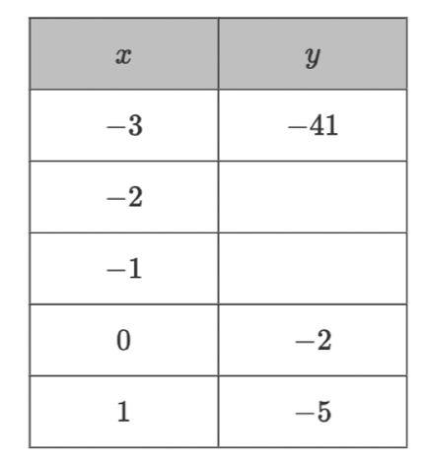
$$-20$$
$$-7$$

- A quadratic equation is shown.
$$y=-{(x+1)}^{2}+9$$
What is the axis of symmetry of the given equation?
$$x=-1$$

